Health and Wellness App

Introduction
Project Name: Health Care App
Goal: To design and develop a mobile application that enables users to manage their health
records, book appointments, and access telemedicine services in one platform.
Role: UI/UX Designer and Researcher
Tools Used: Figma, Canva, Google Forms (for research), MS Word.
Team Members:
Madhumathi S
Jothiga S
Kaviya K
Sethuraman A
Santhosh P

Problem Statement
In todays digital world, patients struggle with managing medical appointments, tracking healthdata, and storing reports in a single place. Traditional healthcare systems often lack accessibility and timely communication between doctors and patients. The Health Care App aims to solve these issues by providing a digital platform that connects patients, doctors, and healthcare services conveniently and efficiently.

Target Audience / Personas
Primary Users: Patients (ages 18—60) seeking quick access to healthcare services
Secondary Users: Doctors, healthcare providers, and hospital staff
User Needs:
o Easy appointment scheduling
o Online consultations and prescriptions
o Secure health record storage
o Reminders for medications and checkups
Pain Points:
o Long waiting times at hospitals
o Misplaced medical records
o Difficulty booking appointments manually

User Research
Research Methods:
Online surveys using Google Forms
Interviews with patients and doctors
Observations at a local clinic
Key Findings:
72% of users prefer digital consultation options
65% find it difficult to maintain health records manually
Users need a simple interface with health tracking, reminders, and doctor availability
Insights:
A unified app that manages all aspects of healthcare can reduce hospital crowding, save time, and improve patient experience.

Information Architecture
App Structure (Sitemap):
Health Care App
Home
Health Tips
Upcoming Appointments
Appointments
Doctor Profiles
Records
Upload Reports
View History
Profile
Personal Info
Settings

User Flow / Journey
Example: Booking a Doctor Appointment
Home → Appointments → Select Doctor → Choose Time Slot → Confirm Appointment → Get
Notification
Example: Uploading Health Report
Home → Records → Upload Report → Save → View in History
UI Design
Colors:
o Primary: Light Blue (#8ECDF2)
o Secondary: White (#FFFFFF)
o Accent: Green (#3CB371)
Typography:
o Headings: Poppins Bold
o Body Text: Roboto Regular
Components:
o Rounded buttons, card-style doctor listings, and minimal icons

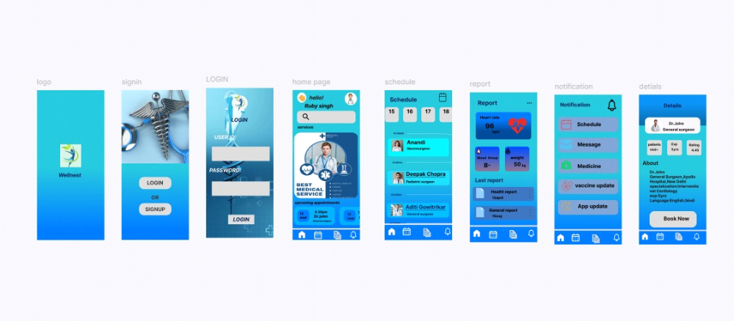
Prototype & Interactions
Created in Figma with navigation and smooth transitions between pages.
Tap animations between home and appointment screens
Hover effects on buttons
Slide transitions for viewing medical records

Conclusion
The Health Care App provides a seamless experience for managing health digitally. It bridges the gap between patients and healthcare providers, ensuring better accessibility and convenience.
Thank You!

